A membership with England Netball
Affiliate with SNTA

- Creating an ENgage account for adult and child
- Adding a child to an existing adult account
- How to join your account with Shan Netball Training Academy
Creating an account on ENgage
Getting Prepared
ENgage is a self-service platform, which means the user is required to make their own account. Please make sure you have your details ready before heading to ENgage, so creating your profile is an easy and quick process.
If you are setting up an account on behalf of a minor, you are required to create an account for yourself, too. This allows you to have more control over your child’s payments: as yours and your child’s accounts will be linked together, you are able to purchase their club memberships through your own profile. This does not mean you will be required to purchase a membership for yourself if you do not need one.
Creating an adult and child account
- To start, please visit https://engage.englandnetball.co.uk
- Select ‘Create Account’ underneath the login box
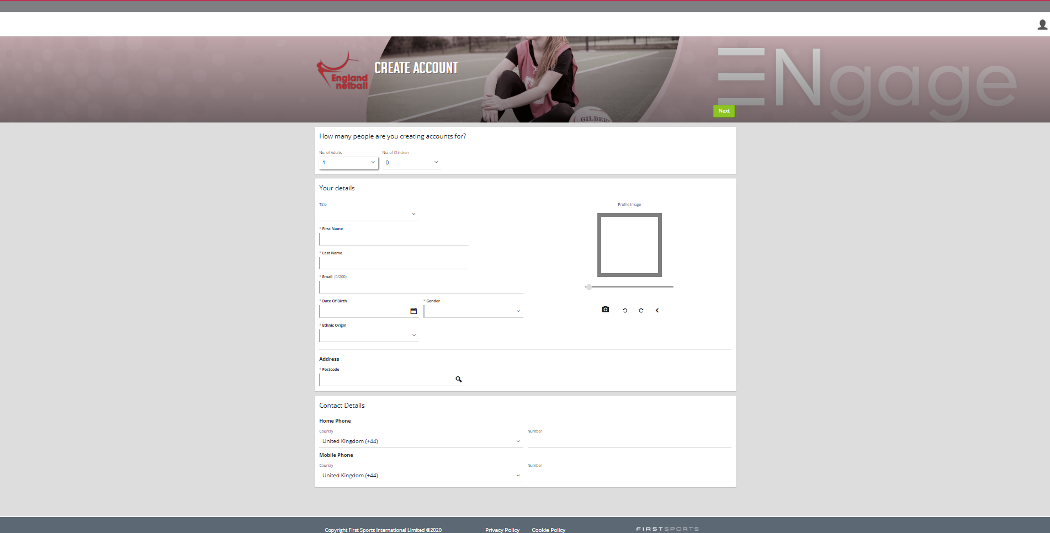
- In order to create an account for yourself, select ‘1 adult’ and ‘1 Child’ in the drop-down menus
- Enter your title, name, email address, date of birth, gender, ethnic origin and postcode
- Press the icon to search for your home address (If your address can not be found, please manually enter your address into the fields)
- Enter your mobile and/or home phone number
- Select ‘Next’
- Enter your emergency contact details, including their name, tel number, email address and their relationship to you
- Enter any medical details in the required field (If this does not apply, please enter ‘N/A’
- Tick the Cookie policy and the ENgage terms and conditions boxes, to accept our user agreements
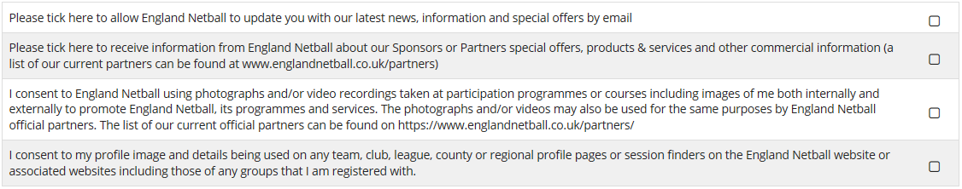
- If you would like to receive updates, news and offers from England Netball, make sure the first box is selected

- Select ‘Next’ to proceed to the next page.
- If you hold any health conditions, please click the appropriate boxes (If you do not wish to disclose this information, please select ‘prefer not to say’ for each question)
- Select ‘Confirm’
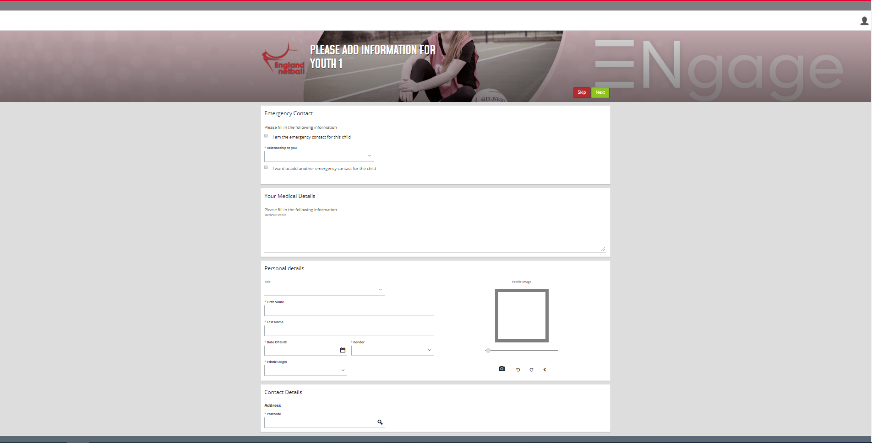
- If you are the child’s emergency contact, click the first tick box
- Select their relationship to you, from the drop-down list
- To add an emergency contact for the child, that is not you, please click the tick box and enter the requested fields
- Enter any medical details in the required field (If this does not apply, please enter ‘N/A’
- Enter your child’s title, name, date of birth, gender and ethnic origin
- If the child’s address differs to yours, please manually change the details
- Click ‘Next’
- If your child holds any health conditions, please click the appropriate boxes (If you do not wish to disclose this information about your child, please select ‘prefer not to say’ for each question)
- Select ‘Confirm’
- Once you can confirm that the information displayed is correct, press ‘Confirm’
The details of your account, including your ENA ID (England Netball Affiliation number) and a password reset will be emailed to you from noreply@first-sports.com. Please monitor your junk folder, if the link is not in your inbox as the password re-set link is only valid for 24 hours.
Please make a note of your ENA ID and password, as you will need to enter these credentials each time you wish to log in to ENgage.

How to add a child to an existing parent account
Please follow these instructions, in order to add a child account under a parent account:
- Log into ENgage
- Click ‘Personal Details’
- Select ‘Relationships’ from the menu on the left hand side
- Click ‘Add Youth’
- Select from the drop-down list your relationship
- Enter your child’s credentials
- Select ‘Next’
- Enter the child’s emergency contact details
- Select from the options regarding medical/health conditions (If you do not wish to, please select ‘Prefer not to say’ from the options)
- Click ‘Confirm’
- Read-over the displayed summary
- Click ‘Confirm’
This will then create a relationship link for you both from the outset.
How to join your account to your child’s club directory
Please follow these instructions, to link to a club directory:
- Log into your ENgage account
- Click on the ‘Directory’ button
- Click on the funnel symbol on the right hand-side of the screen
- Select the ‘+’ symbol
- Select ‘Reference’
- Enter the club ID (Shan Netball 2058717)
- Click ‘Apply’
- Select the small circle to the left of the club name
- Click ‘Join’
- Select from individual type dropdown, as appropriate
- Select ‘Save’

